# **Table of Contents**

Table of Contents 1

Steps to Configure Route 53 2

**Diagram - Class** 2

**Diagram** 3

**High-level steps** 3

**Screenshots to see Name servers of your Domian** 5

**Screenshots for hosted zone creation** 6

**Screenshots to update the name servers on your domain** 8

**Screenshots for Simple Record Policy** 9

**Screenshots for Sime Record Creation with Alias option** 11

**Screenshots for Failover Record Policy** 13

**Screenshots for Geolocation Record Policy** 21

**Screenshots for Latency-Based Record policy** 25

# Steps to Configure Route 53

### **Diagram - Class**

### **Diagram**

### **High-level steps**

1. Create a VPC.
2. Create an Internet Gateway and attach it to the VPC.
3. Create one public subnets: one in Availability Zone 2a
4. Create a route table
5. Associate the Internet Gateway, and link it to the public subnets in Availability Zones 2a
6. Create a security group with inbound rules for SSH and HTTP access.
7. Launch an EC2 instance in the public subnet in AZ 2a
8. Connect to public server and install httpd

*sudo su*

*sudo yum install httpd -y*

*sudo systemctl start httpd*

*sudo systemctl enable httpd*

*cd /var/www/html*

*vi index.html*

*<h1>Welcome </h1>*

*ESC then :wq*

*Hit enter*

1. Create your domain name
2. Create hosted zone in route 53
3. Create A type Record in hosted zone

### **Screenshots to see Name servers of your Domian**

step-by-step guide (with example screenshots) to create an **A record** in Route 53 to route traffic directly to an **EC2 instance** using its public IP address. This setup assumes that your application is accessible via the EC2 instance’s public IP

After signing in, click on **My Products** in the top-right corner.

Scroll down to **Domains**, and find the domain for which you want to view the name servers

Click on **DNS** to open the DNS management page

Under the **Nameservers** section, you will see the current name servers for your domain.

### **Screenshots for hosted zone creation**

Go to the [Route 53 Console](https://console.aws.amazon.com/route53)

In the **DNS management** section, choose **Hosted Zones**.

Click **Create hosted zone**

Enter the **Domain name**

Specify the type as **Public Hosted Zone**

**Update Domain Name Servers (DNS) with Registrar**

If you purchased your domain from another registrar (e.g., GoDaddy), update the name servers to the ones provided by Route 53.

Copy the name servers from route53 and update on your domain. When copying each name server, simply exclude the final period (".") if it appears at the end.

### **Screenshots to update the name servers on your domain**

Choose Change Nameservers on your domain

Enter nameservers from route53

Click on Save

### **Screenshots for Simple Record Policy**

**Configure DNS Records**

After creating the hosted zone, add DNS records to route traffic to EC2 instance

Click **Create Record** in the hosted zone

In the **Record type** dropdown, select **A**

In the **Value** field, enter the public IP address

Choose **Routing policy** as Simple routing.

Click **Create records**

**Test Accessing Your Application**

Wait a few minutes for DNS changes to propagate

Open **Internet Explorer** or any web browser.

In the address bar, type your domain name and press **Enter**

**If Route 53 and your DNS configuration are correct, your website or service should load as expected.**

### **Screenshots for Sime Record Creation with Alias option**

**Step-by-step guide with screenshots to create an Alias record in Route 53 to route traffic to your load balancer once you’ve confirmed that your application is accessible using the load balancer's DNS name.**

In the hosted zone for your domain, click on **Create Record**

**Record type**: Choose **A - IPv4 address**

**Alias**: Select **Yes** to enable the alias

**Route traffic to**: Choose **Alias to Application and Classic Load Balancer**.

**Region**: Select the AWS region where your load balancer is deployed

**Choose Load Balancer**: In the dropdown, select your load balancer from the list

Click **Create records**

Test Accessing Your Application

Wait a few minutes for DNS changes to propagate

Open a browser and go to your custom domain. It should now route to your application via the load balancer.

### **Screenshots for Failover Record Policy**

Define Primary and Secondary Resources

Identify the primary resource (server,) and secondary resource (backup IP or server)

Created one instance under Oregon Region

Created another instance under Mumbai Region

Set Up Health Checks

From the left navigation pane, click on **Health Checks**.

Click **Create health check**.

**Name**: Enter a unique name for the health check.

Select Resource - Endpoint

Specify Endpoint: IP Address

IP address: Provide the primary resource's IP address

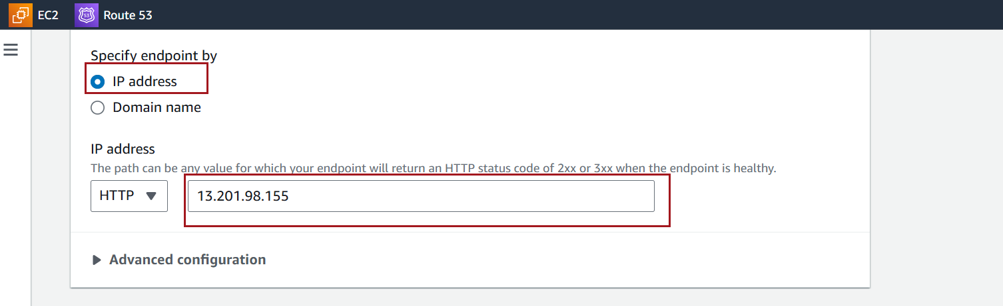

click **Create health check**.

Wait for a few minutes; it typically takes around 2–3 minutes for Route 53 to complete the initialization phase.

After this, the health check will either show **"Healthy"**

From the Route 53 console, go to **Hosted Zones** and select your domain

lick **Create record**.

**Configure Primary Record**:

**Record Type**: Choose **A**

**Value**: Enter the IP address

**Routing Policy: Choose Failover.**

**Failover Record Type**: Set this as **Primary**

**Associate Health Check**: Select the health check you created for the primary resource

Record ID – Enter record ID

Click **Create records** to save

**Create the Secondary Failover Record**

**Click Create record again to** add the secondary failover record

**Configure Secondary Record**:

**Record Type**: Use the same record type as the primary

**Value**: Enter the IP address or DNS name of the secondary

**Routing Policy**: Choose **Failover**.

**Failover Record Type**: Set this as **Secondary**

**Record ID: Any ID**

**Test the Failover Configuration**

Wait a few minutes for DNS changes to propagate

Open a browser and go to your custom domain. It should now route to your application via the load balancer.

**Temporarily take the primary resource offline**

**Check if Route 53 detects the primary as unhealthy**

Check if Route 53 detects the primary as unhealthy and automatically routes traffic to the secondary.

### **Screenshots for Geolocation Record Policy**

End Resources Set Up to Handle Location-Based Traffic

Ensure you have different servers, for each geographic location where you want to direct traffic.

For example, if you want to route North American users to a US-based server and European users to an EU-based server, set up these resources in advance

Created an instance in US WEST(Oregon)

Created another instance in Asia Pacific (Mumbai)

In the Route 53 dashboard, go to **Hosted Zones**.

Select the hosted zone for the domain you want to configure geolocation-based routing for.

/

Click **Create record**.

**Record Type**: Choose the record type as **A**

**Value**: Enter the public IP address of the instance created in US WEST(Oregon)

**Routing Policy**: Select **Geolocation**.

**Location**:

* Choose the location to route traffic based on user geography:
  + **Continent**: E.g., North America, Europe.
  + **Country**: E.g., United States, India.
  + **State**: For the United States, you can also choose a specific state (e.g., California).

Click **Create records** to save

**Add Additional Geolocation Records (Optional)**

Repeat the above steps for other geographic location Asia Pacific(Mumbai) you want to route traffic to. For example, you might create records for different continents or countries.

**Wait a few minutes for DNS changes to propagate**

Open a browser and go to your custom domain on the server from the **same continent**. It should now route to your application via the load balancer.

From North America location server

From Asia Pacific location server

### **Screenshots for Latency-Based Record policy**

For each AWS region you want to route traffic to based on latency, follow these steps:

**Record Type**: Choose **A**

**Value**: Enter the public IP address

**Routing Policy**: Select **Latency**.

**Region**: Choose the AWS region where the endpoint is located

Click **Create records**

**Repeat the above steps to create a latency-based record for each additional region where you have resources.**

Open a browser and go to your custom domain on the server from the **same location US WEST(Oregon)**. It should now route to your application via the load balancer.

From US WEST(Oregon) location server

